Mrs. Ricks’ Classroom News
Week of December 11th
Phonics Skill:  -Read and spell words containing the digraph “aw” as in yawn  -There are no new tricky heart words for the week. We will review these tricky words: so, no, of, all, some, from, word, are, were, have, one, once, do, two, the, who, said, says, was, when, why, where, what, which, here, there they, their, my, by, you, your, because, should, would, could, down. (Tricky heart words are words we can’t sound out. We have to know them by heart. We practice spelling and reading our heart words.)  Reading:  -We will read passages and books containing words with digraph “aw” during guided reading group.  Grammar:  -Review Nouns and Verbs  Writing:  -“How to” Writings- Think about something you know how to do and the steps involved. Draw pictures and write the steps for each in the correct order.  Math:  -Topic 7- Extend the Counting Sequence to 120  -Take Topic 7 Math test on Thursday  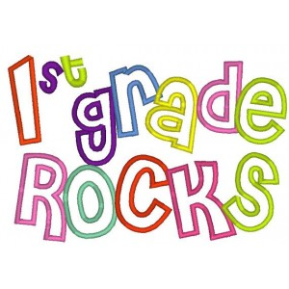 | Core:  -Three World Religions (Judaism, Christianity, Islam) *As we focus on each religion, each one will be informational as I will focus on the basic facts of the religions and what they stand for. The objective is that the students are exposed to the different religions that are in our world.  Upcoming Dates:  *Thursday, December 21st- Grinch Day for 1st Graders (more info to follow)  *Friday, December 22nd- Our classroom winter party 8:30-9:45 AND pajama day!!!  *December 25th-January 5th- Winter Break  *Monday, January 8th- Staff Work Day  *Tuesday, January 9th- Students return to school  *Wednesday, January 10th- First Grade Coffee Talk with Mrs. Alfonso (8:00-9:00 am in the cafeteria)  Specials Schedule:  Monday, 12/11- P.E./Music  Tuesday, 12/12- Art  Wednesday, 12/13- Music/P.E.  Thursday, 12/14- Tech/Library  Friday, 12/15- P.E./Music

