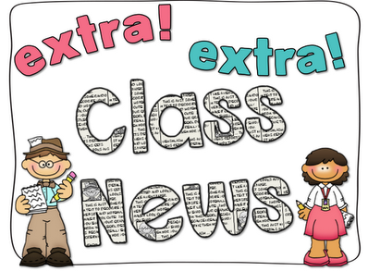
Mrs. Ricks’ Classroom News
Week of December 4th
Phonics Skill:  -Read and spell words containing the vowel teams “ou” as in (cloud) and “oi” as in (broil)  -There are no new tricky heart words for the week. We will review these tricky words: so, no, of, all, some, from, word, are, were, have, one, once, do, two, the, who, said, says, was, when, why, where, what, which, here, there they, their, my, by, you, your, because, should, would, could. (Tricky heart words are words we can’t sound out. We have to know them by heart. We practice spelling and reading our heart words.)  Reading:  -We will read passages and books containing words with the vowel teams “ou” and “oi” during guided reading group.  Grammar:  -Identify verbs  Knowledge/Writing:  -Our Knowledge Unit is “Early American Civilizations.” We will learn about the Inca civilization. The main focus will be on farming, establishment of cities and government, as well as religion. Through writing, students will show what they have learned about the Inca civilization.  -Vocabulary words we will focus on: collecting, possessions, villagers, forbidden, gasping, honor, archaeologist, existence, raging, ruins, trek  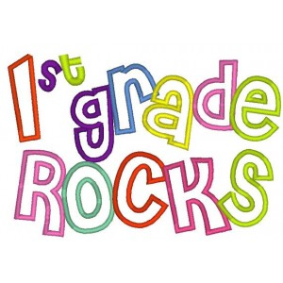 | Math:  -Topic 7- Extend the Counting Sequence to 120  Core:  -Three World Religions (Judaism, Christianity, Islam) *As we focus on each religion, each one will be informational as I will focus on the basic facts of the religions and what they stand for. The objective is that the students are exposed to the different religions that are in our world.  Upcoming Dates:  *Monday, December 4th- My class will get to shop at the Polar Pals Gift Shop during their Specials (12:45-1:15)  Thursday, December 21st- Grinch Day for 1st Graders (more info to follow)  *Friday, December 22nd- Our classroom winter party 8:30-9:45 AND pajama day!!!  *December 25th-January 5th- Winter Break  *Monday, January 8th- Staff Work Day  *Tuesday, January 9th- Students return to school  *Wednesday, January 10th- First Grade Coffee Talk with Mrs. Alfonso (8:00-9:00 am in the cafeteria)  Specials Schedule:  Monday, 12/04- Tech/Library  Tuesday, 12/05- P.E./Music  Wednesday, 12/06- Art  Thursday, 12/07- Music/P.E.  Friday, 12/08- Tech/Library

