Mrs. Ricks’ Classroom News
Week of February 20th
Phonics Skill:  -We will learn when to double a consonant at the end of a word before adding -ed and -ing.  -Our new tricky word for the week is how. We will review these tricky words: so, no, of, all, some, from, word, are, were, have, one, once, do, two, the, who, said, says, was, when, why, where, what, which, here, there they, their, my, by, you, your, because, should, would, could, down, Sunday, Monday, Tuesday, Wednesday, Thursday, Friday, Saturday, today, yesterday, and tomorrow. (Tricky heart words are words we can’t sound out. We have to know them by heart. We practice spelling and reading our heart words.)  Reading:  -Students will read a variety of passages while reviewing previously taught phonics skills. They will answer written comprehension questions by going back to find evidence in the text to support their answers. Students will then write the answers in complete sentences.  Grammar:  -Review Nouns, Verbs, and Adjectives  Writing:  -Persuasive Writing- We will read the book, Hey, Little Ant and also research some facts about ants. How are they helpful? How are they harmful? Students will then write a letter to the boy in the book. They will either try to persuade him to squish the ant, or they will try to persuade him not to squish the ant.  Math:  -Topic 11- Use Models and Strategies to Subtract with Tens and Ones  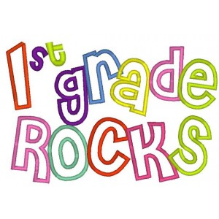 | Core:  -American Symbols and Figures (From Colonies to Independence)  Upcoming Dates:  *Monday, February 19th- Teacher Work Day (No students)  Monday, February 19th- Pizza Hut Affinity night, 4-8 Windsor  Wednesday, March 6th- Author Visit/Book Swap, 8:40-11:30  Wednesday, March 6th- Backyard Bird Affinity Night  Specials Schedule:  Tuesday, 2/20- P.E./Music  Wednesday, 2/21- Art  Thursday, 2/22- Music/P.E.  Friday, 2/23- Tech/Library

