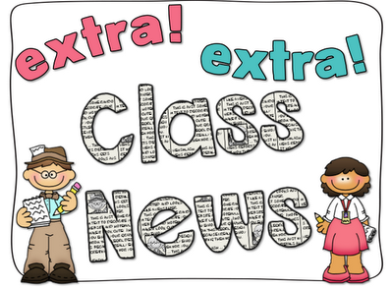
Mrs. Ricks’ Classroom News
Week of January 22nd
Phonics Skill:  -Read and spell words with the r-controlled vowel “or”  -Our new tricky heart words for the week are: today, yesterday, and tomorrow. We will review these tricky words: so, no, of, all, some, from, word, are, were, have, one, once, do, two, the, who, said, says, was, when, why, where, what, which, here, there they, their, my, by, you, your, because, should, would, could, down, Sunday, Monday, Tuesday, Wednesday, Thursday, Friday, Saturday. (Tricky heart words are words we can’t sound out. We have to know them by heart. We practice spelling and reading our heart words.)  Reading:  -Read books and passages with words containing “or.”  Grammar:  -Nouns (common and proper)  -Verbs  Knowledge/Writing:  -We will finish up our Knowledge Unit on Astronomy. The topics that we will focus on are:  *History of Space Exploration and Astronauts  *Exploration of the Moon  *The Solar System  Through writing, students will record observations and facts about outer space. Vocabulary words- astronaut, launch, rockets, spacecraft, technology, determined, disaster, historic, missions, nervously, abundant, accomplish, inner, solar, unique, categorize, outer, probes, violent  Math: Topic 9- Compare Two-Digit Numbers  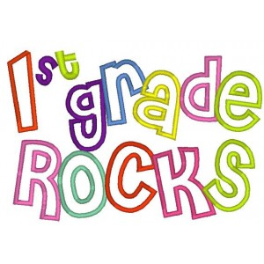 | Core:  -Finish up our States of Matter Unit (Solid, Liquid, Gas)  -Begin our Sound Unit (Sound can make matter vibrate and vibrating matter can make sound.)  Upcoming Dates:  *Wednesday, January 31st- 100’s Day Celebration Snack Items due  *Friday, February 2nd- 100th Day of School (100th Day Project)  *Monday, February 12th- Valentine’s Day Snack items due  *Wednesday, February 14th- Valentine’s Day (Your child may bring his/her Valentine’s cards and decorated box/bag.)  Specials Schedule:  Monday, 1/22- P.E./Music  Tuesday, 1/23- Art  Wednesday, 1/24- Music/P.E.  Thursday, 1/25- Tech/Library  Friday, 1/26- P.E./Music

