Mrs. Ricks’ Classroom News
Week of January 9th
Phonics Skill:  -Read and spell words with the r-controlled vowel “er”  -Our new tricky heart words for the week are: Sunday, Monday, Tuesday, Wednesday, Thursday, Friday, and Saturday. We will review these tricky words: so, no, of, all, some, from, word, are, were, have, one, once, do, two, the, who, said, says, was, when, why, where, what, which, here, there they, their, my, by, you, your, because, should, would, could, down. (Tricky heart words are words we can’t sound out. We have to know them by heart. We practice spelling and reading our heart words.)  Reading:  -Read books and passages with words containing “er.”  Grammar:  -Introduce Contractions  Knowledge/Writing:  - Our 6th Knowledge unit is Astronomy. In this domain, students will be introduced to the solar system. They will learn that Earth is just one of the many different celestial bodies within the solar system. Students will learn about the sun, moon, and stars and how the earth orbits around the sun. Through writing, students will record observations and facts about outer space. Vocabulary words- atmosphere, gas, rays, shadow, surface, gravity, horizon, orbit, planet, rotates, debris, dusk, meteor, telescopes, universe.  Math:  -Topic 8- Understand Place Value  -Math test on Friday  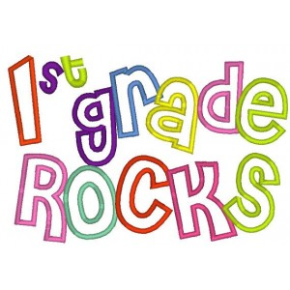 | Core:  -States of Matter (Solid, Liquid, Gas)  Upcoming Dates:  *Tuesday, January 9th- Students return to school  *Wednesday, January 10th- First Grade Coffee Talk with Mrs. Alfonso (8:00-9:00 am in the cafeteria)  *Monday, January 15^{th-} No School (Dr. Martin Luther King, Jr. Day)  *Tuesday, January 16th- PTO Meeting (8:00 am cafeteria)  *Wednesday, January 17th- Qdoba Affinity Night (4:00-8:00 pm)  Specials Schedule:  Tuesday, 1/09- Art  Wednesday, 1/10- Music/P.E.  Thursday, 1/11- Tech/Library  Friday, 1/12- P.E./Music

