Mrs. Ricks’ Classroom News
Week of March 18th
Phonics Skills:  -We will review previously taught vowel teams: oi, oo, and ou.  -We will review these tricky words: so, no, of, all, some, from, word, are, were, have, one, once, do, two, the, who, said, says, was, when, why, where, what, which, here, there they, their, my, by, you, your, because, should, would, could, down, Sunday, Monday, Tuesday, Wednesday, Thursday, Friday, Saturday, today, yesterday, how, and tomorrow. (Tricky heart words are words we can’t sound out. We have to know them by heart. We practice spelling and reading our heart words.)  Reading:  -Students will read a variety of passages while reviewing previously taught phonics skills. They will answer written comprehension questions by going back to find evidence in the text to support their answers. Students will then write the answers in complete sentences.  Grammar:  -Statements, Questions, and Exclamations  -Plural Nouns and Adjectives  Knowledge/Writing:  -Our 8th Knowledge Unit is “Animals and Habitats.” We will learn about animals of the arctic, desert, savanna, and forest habitats. Vocabulary words that we will focus on: habitat, shelter, survive, adapted, blubber, burrow, exposed, tundra, camouflage, carnivore, herbivores, omnivore, scavengers, coexist, hardy, predators, prey, climate, species, store, temperate, territory  Through writing, students will record observations and facts about animals and their habitats.  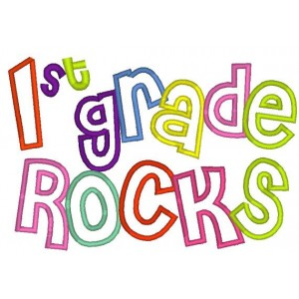 | Math:  -Topic 13- Tell Time to the Hour and Half Hour  Core:  -Early Exploration of the American West (Daniel Boone, The Louisiana Purchase, Lewis and Clark, Sacagawea)  Upcoming Dates:  March 11th-15th- Spring Break- No School  Wednesday, March 20th- Author visit (Megan  Benedict)  Thursday, April 4th- First Grade Field Trip to IMAX  Friday, April 5th- Cozy Reading (10:20-10:50)  Friday, April 19th- No School, Staff Work Day  April 22nd-26th- Book Fair  Wednesday, April 24th- Field Trip to Gardens on Spring Creek (Ricks and Hause)  Thursday, April 25th- First Grade Music Program, 6:30 pm  Specials Schedule:  Monday, 3/18- Art  Tuesday, 3/19- Music/P.E.  Wednesday, 3/20- Tech/Library  Thursday, 3/21- P.E./Music  Friday, 3/22- Art

