Mrs. Ricks’ Classroom News
Week of March 25th
Phonics Skills:  -We will read and spell words with double consonants ‘pp’, ‘bb’, ‘dd’, ‘ff’, and ‘ll.’  -We will review these tricky words: so, no, of, all, some, from, word, are, were, have, one, once, do, two, the, who, said, says, was, when, why, where, what, which, here, there they, their, my, by, you, your, because, should, would, could, down, Sunday, Monday, Tuesday, Wednesday, Thursday, Friday, Saturday, today, yesterday, how, picture, and tomorrow. (Tricky heart words are words we can’t sound out. We have to know them by heart. We practice spelling and reading our heart words.)  Reading:  -Students will read a variety of passages while reviewing previously taught phonics skills. They will answer written comprehension questions by going back to find evidence in the text to support their answers. Students will then write the answers in complete sentences.  Grammar:  -Statements, Questions, and Exclamations  Knowledge/Writing:  -We will finish up our Knowledge Unit on “Animals and Habitats.” We will learn about animals of the rainforest, freshwater, and saltwater habitats. We will also learn about habitat destruction and endangered species. Vocabulary words that we will focus on: canopy, colonies, humid, stalk, amphibious, float, freshwater, gills, waterproof, plankton, regeneration, shallow, slopes, valleys, destroy, endanger, endangered species, extinction  -Through writing, students will record observations and facts about animals and their habitats.  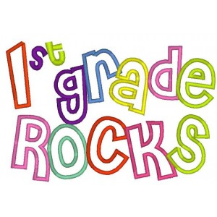 | Math:  -Topic 13- Tell Time to the Hour and Half Hour  -Take test on Thursday, 3/28  Core:  -Inside the Earth (Layers of the Earth, Earth’s Land Changes, Volcanoes and Geysers)  Upcoming Dates:  Thursday, April 4th- First Grade Field Trip to IMAX  Friday, April 5th- Cozy Reading (10:20-10:50)  Friday, April 19th- No School, Staff Work Day  April 22nd-26th- Book Fair  Wednesday, April 24th- Field Trip to Gardens on Spring Creek (Ricks and Hause)  Thursday, April 25th- First Grade Music Program, 6:30 pm  Specials Schedule:  Monday, 3/25- Music/P.E.  Tuesday, 3/26- Tech/Library  Wednesday, 3/27- P.E./Music  Thursday, 3/28- Art  Friday, 3/29- Music/P.E.

