Mrs. Ricks’ Classroom News
Week of May 6th
Reading:  -Students will continue practicing reading their character parts from our reader’s theater scripts. They will be acting out the following fairy tales in our classroom on Friday the 10th: Three Billy Goats Gruff, Jack and the Beanstalk, Sleeping Beauty, and Hansel and Gretel. They made their own props too!  Grammar:  -Review Adjectives and Prepositions  Writing:  -Research and Note Taking on Astronauts  Math:  -Step Up to 2nd Grade Unit- (even and odd numbers, use arrays to find totals, add on a hundred chart, add 2-digit numbers)  -There will be no more math homework coming home.  Core:  -Space (Sun, Moon, Stars)  *Why do stars come out at night?  *How can stars help us if we’re lost?  *Sun and other stars/constellations  *Earth’s orbit and rotation  *Moon and its phases  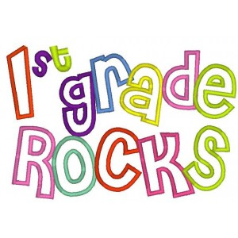 | Upcoming Dates:  Wednesday, May 15th- Bike to School Day  Thursday, May 23rd- Field Day that morning and Family Picnic Luncheon from 12:15-12:45  Friday, May 24th- No School- Teacher Work Day  Monday, May 27th- No School- Memorial Day  Thursday, May 30th- Last Day of School (1/2 day)- 11:08 Dismissal  Specials Schedule:  Monday, 5/06- Tech/Library  Tuesday, 5/07- P.E./Music  Wednesday, 5/08- Art  Thursday, 5/09- Music/P.E.  Friday, 5/10- Tech/Library

