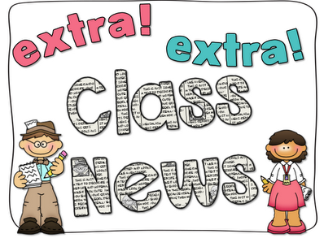
Mrs. Ricks’ Classroom News
Week of November 13th
Phonics Skill:  -Read and spell words containing the vowel team “oo” (as in spoon)  -Our new tricky heart word for the week is: because. We will review these tricky words: so, no, of, all, some, from, word, are, were, have, one, once, do, two, the, who, said, says, was, when, why, where, what, which, here, there they, their, my, by, you, your. (Tricky heart words are words we can’t sound out. We have to know them by heart. We practice spelling and reading our heart words.)  Reading:  -We will read passages and books containing words with the vowel team “oo” during guided reading group.  Knowledge/Writing:  -Our 5th Knowledge Unit is “Early American Civilizations.” This domain includes a study of the Maya, Aztec, and Inca civilizations. The main focus will be on farming, establishment of cities and government, as well as religion. Through writing, students will compare and contrast each of these civilizations.  -Vocabulary words we will focus on:  harvest, hurricane, maize, shore, plain, temple, thrilled, constructing, market, pyramid, tomb, accurate, festivals, invented, observatories, telescopes  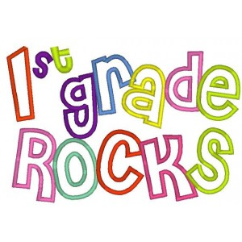 | Math:  -Topic 5- Finish up Addition and Subtraction Equations on Monday, 11/13  -Topic 5 Math Test on Tuesday 11/14  -Complete a “Mystery Math” packet and Thanksgiving Math the rest of the week  Core:  -Early Explorers and Settlers  *The story of Columbus’s first voyage to the Americas  *Spain’s search for gold in Mexico and America  *The conquests of Cortes and Pizarro  *The story of the Lost Colony of Roanoke and the founding of Jamestown  *The Pilgrims’ voyage on the Mayflower  *The founding of Massachusetts Bay Colony by the Puritans  Upcoming Dates:  -November 20th-24th- Thanksgiving Break  Specials Schedule:  Monday, 11/13- Art  Tuesday, 11/14- Music/P.E.  Wednesday, 11/15- Tech/Library  Thursday, 11/16- P.E./Music  Friday, 11/17- Art

