Mrs. Ricks’ Classroom News
Week of August 21st
Literacy (Reading/Phonics Skill):  -Begin learning our Daily 4 routines (Word Work, Work on Writing, Read to Self, Read with Teacher)  -We will be working on building our stamina, reviewing what a learner looks like, and focusing on the importance of being responsible while completing our independent work.  -Review reading and spelling cvc (consonant/vowel/consonant) words  Grammar:  -Introduce and identify nouns (person, place, thing)  Handwriting:  -Practice writing the following letters neatly while using correct letter formation (Aa, Pp, Nn, Cc, Gg, Ii, Oo, Tt, Dd, Mm, Ff, Vv)  Math:  -Topic 1- Solve Addition and Subtraction Problems Using Multiple Strategies  Core:  -Maps and Continents  *Name and locate our continent, country, state, and community/*Use map keys and symbols/*Directions on a map/*Location of oceans/*Location of the Equator and Northern & Southern Hemispheres | Upcoming Dates:  Thursday, 8/24- Back-to-School Night: Two identical sessions to choose from, 4:00 or 4:45. I will share a presentation highlighting all of the important areas of our year in first grade.  Come with any questions you may have.  Wednesday, 8/30- I will be giving my students the DIBELS Literacy Assessment at school. They will have a substitute teacher this day.  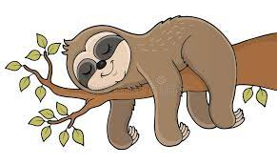
Specials Schedule:  Monday, 8/21- Tech/Library  Tuesday, 8/22- P.E./Music  Wednesday, 8/23- Art  Thursday, 8/24- Music/P.E.  Friday, 8/25- Tech/Library | Just a Reminder:  *Please send in a water bottle and snacks with your child daily.  *Have your child bring his/her library book back to school on Tech/Library days.

