Mrs. Ricks’ Classroom News
Week of December 18th
Phonics Skill:  -Review all phonics skills that have been previously taught  -There are no new tricky heart words for the week. We will review these tricky words: so, no, of, all, some, from, word, are, were, have, one, once, do, two, the, who, said, says, was, when, why, where, what, which, here, there they, their, my, by, you, your, because, should, would, could, down. (Tricky heart words are words we can’t sound out. We have to know them by heart. We practice spelling and reading our heart words.)  Reading:  -Partner reading during guided reading groups  Grammar:  -Review Nouns and Verbs  Writing:  - “How to” Writings- “How to Build a Snowman” and “How to Catch an Elf” (Students will write their steps in the correct order for both writing activities and then complete a craft to go along with each writing.)  Math:  -Topic 8- Understand Place Value  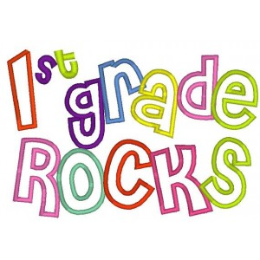 | Core:  -Fun Gingerbread Unit- We will read The Gingerbread Man Loose in the School, The Gingerbread Bear, and The Gingerbread Baby. We will compare stories by focusing on Story Elements- characters, setting, problem, and solution.  Upcoming Dates:  *Thursday, December 21st- Grinch Day for 1st Graders  *Friday, December 22nd- Our classroom winter party 8:30-9:45 AND pajama day!!!  *December 25th-January 5th- Winter Break  *Monday, January 8th- Staff Work Day  *Tuesday, January 9th- Students return to school  *Wednesday, January 10th- First Grade Coffee Talk with Mrs. Alfonso (8:00-9:00 am in the cafeteria)  Specials Schedule:  Monday, 12/18- Art  Tuesday, 12/19- Music/P.E.  Wednesday, 12/20- Tech/Library  Thursday, 12/21- P.E./Music  Friday, 12/22- Art

