Mrs. Ricks’ Classroom News
Week of February 12th
Phonics Skill:  -We will review previously taught skills.  -We will review these tricky words: so, no, of, all, some, from, word, are, were, have, one, once, do, two, the, who, said, says, was, when, why, where, what, which, here, there they, their, my, by, you, your, because, should, would, could, down, Sunday, Monday, Tuesday, Wednesday, Thursday, Friday, Saturday, today, yesterday, and tomorrow. (Tricky heart words are words we can’t sound out. We have to know them by heart. We practice spelling and reading our heart words.)  Reading:  -Read books and passages with words containing previously taught phonics skills  Grammar:  -Review Nouns, Verbs, and Adjectives  Writing:  -Persuasive Writing- After reading The Day the Crayons Quit, students will persuade their favorite crayon not to give up.  Students will state their opinion on their page. Then they will write three reasons why. Last, they will write their concluding sentence.  Other writings will be: “Persuade Your Teacher to Get a Class Pet” and “Persuade Your Teacher to Let You Have a Longer Recess.”  Math:  -Finish up Topic 10- Use Models and Strategies to Add with Tens and Ones  -Take Topic 10 Math Test  -Start Topic 11- Use Models and Strategies to Subtract with Tens and Ones  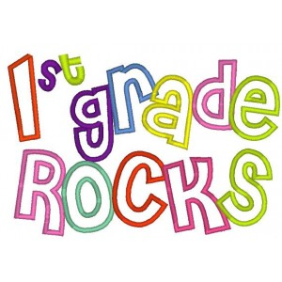 | Core:  -American Symbols and Figures (From Colonies to Independence)  Upcoming Dates:  *Monday, February 12th- Valentine’s Day Snack items due  *Wednesday, February 14th- Valentine’s Day (Your child may bring his/her Valentine’s cards and decorated box/bag.)  *Monday, February 19th- Teacher Work Day (No students)  Specials Schedule:  Monday, 2/12- Tech/Library  Tuesday, 2/13- P.E./Music  Wednesday, 2/14- Art  Thursday, 2/15- Music/P.E.  Friday, 2/16- Tech/Library

