Mrs. Ricks’ Classroom News
Week of February 26th
Phonics Skills:  -We will review the spelling alternatives for /k/ (c, k, ck, cc), /ch/ (ch, tch), /g/ (g, gg), and /j/ (j, g, ge).  -We will also review the rules for doubling/not doubling the final consonant in a word before adding -ed or -ing.  -We will review these tricky words: so, no, of, all, some, from, word, are, were, have, one, once, do, two, the, who, said, says, was, when, why, where, what, which, here, there they, their, my, by, you, your, because, should, would, could, down, Sunday, Monday, Tuesday, Wednesday, Thursday, Friday, Saturday, today, yesterday, how, and tomorrow. (Tricky heart words are words we can’t sound out. We have to know them by heart. We practice spelling and reading our heart words.)  Reading:  -Students will read a variety of passages while reviewing previously taught phonics skills. They will answer written comprehension questions by going back to find evidence in the text to support their answers. Students will then write the answers in complete sentences.  Grammar:  -Statements and Questions  -Plural Nouns  Knowledge/Writing:  -Our 7th Knowledge Unit is “The History of the Earth.” We will learn about the layers of the earth, volcanoes, geysers, rocks, minerals, and fossils. Through writing, students will show what they have learned about the history of the earth.  -Vocabulary words we will focus on: equator, geologist, geology, pressure, surface, core, crust, eroded, layer, mantle, erupts, liquid, molten, solid, volcano, destructive, geysers, lava, magma.  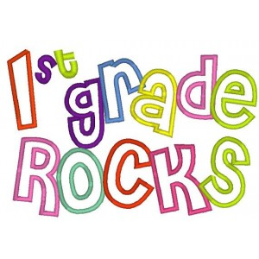 | Math:  -Finish up Topic 11- Use Models and Strategies to Subtract with Tens and Ones  -Take Topic 11 Math Test  -Start Topic 12- Measurement (There will be no homework for this topic because there is no need for extra practice at home.)  Core:  -American Symbols and Figures (From Colonies to Independence)  Upcoming Dates:  Friday, March 1st- Cozy Reading  Wednesday, March 6th- Author Visit/Book Swap, 8:40-11:30  Wednesday, March 6th- Backyard Bird Affinity Night  March 11th-15th- Spring Break- No School  Specials Schedule:  Monday, 2/26- P.E./Music  Tuesday, 2/27- Art  Wednesday, 2/28- Music/P.E.  Thursday, 2/29- Tech/Library  Friday, 3/01- P.E./Music

