Mrs. Ricks’ Classroom News
Week of March 4th
Phonics Skills:  -We will review previously taught phonics skills.  -We will review these tricky words: so, no, of, all, some, from, word, are, were, have, one, once, do, two, the, who, said, says, was, when, why, where, what, which, here, there they, their, my, by, you, your, because, should, would, could, down, Sunday, Monday, Tuesday, Wednesday, Thursday, Friday, Saturday, today, yesterday, how, and tomorrow. (Tricky heart words are words we can’t sound out. We have to know them by heart. We practice spelling and reading our heart words.)  Reading:  -Students will read a variety of passages while reviewing previously taught phonics skills. They will answer written comprehension questions by going back to find evidence in the text to support their answers. Students will then write the answers in complete sentences.  Grammar:  -Statements, Questions, and Exclamations  -Plural Nouns  Knowledge/Writing:  -Our 7th Knowledge Unit is “The History of the Earth.” We will learn about the layers of the earth, volcanoes, geysers, rocks, minerals, and fossils. Through writing, students will show what they have learned about the history of the earth.  -Vocabulary words we will focus on: characteristics, gemstones, minerals, traces, igneous rock, metamorphic rock, ore, sedimentary rock, sediments, fossil, impression, paleontologist, preserved, debris, excavating, extinct, meteorite, meteors  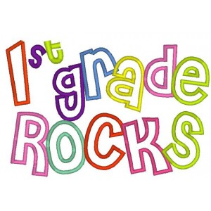 | Math:  -Topic 12- Measurement (There will be no homework for this topic because there is no need for extra practice at home.)  Core:  -Early Exploration of the American West (Daniel Boone, The Louisiana Purchase, Lewis and Clark, Sacagawea)  Upcoming Dates:  Wednesday, March 6th- Author Visit (Michelle Schaub) and Book Swap Day  Wednesday, March 6th- Backyard Bird Affinity Night  Thursday, March 7th- Dress as your favorite book character  Friday, March 8th- Whole school pajama day  March 11th-15th- Spring Break- No School  Wednesday, March 20th- Author visit (Megan Benedict)  Specials Schedule:  Monday, 3/04- Art  Tuesday, 3/05- Music/P.E.  Wednesday, 3/06- No Specials due to author visit and book swap  Thursday, 3/07- Tech/Library  Friday, 3/08- P.E./Music

