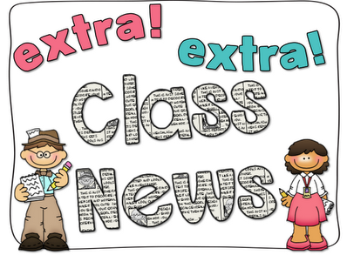
Mrs. Ricks’ Classroom News
Week of November 27th
Phonics Skill:  -Read and spell words containing the vowel team “oo” (as in book)  -Our new tricky heart words for the week are: should, would, could. We will review these tricky words: so, no, of, all, some, from, word, are, were, have, one, once, do, two, the, who, said, says, was, when, why, where, what, which, here, there they, their, my, by, you, your, because. (Tricky heart words are words we can’t sound out. We have to know them by heart. We practice spelling and reading our heart words.)  Reading:  -We will read passages and books containing words with the vowel team “oo” during guided reading group.  Knowledge/Writing:  -Our Knowledge Unit is “Early American Civilizations.” We will learn about the Aztec civilization. The main focus will be on farming, establishment of cities and government, as well as religion. Through writing, students will show what they have learned about the Aztec civilization.  -Vocabulary words we will focus on:  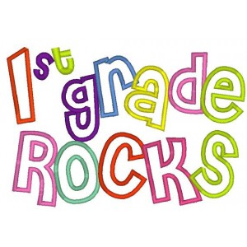  awe, island, legend, scouts, valley, abundance, dredged, float, stationary, emperor, empire, palace, retreat, wealth, courteous, enormous, royalty | Math:  -Topic 6- Represent and Interpret Data (Tally Marks and Graphs)  Core:  -Three World Religions (Judaism, Christianity, Islam) *As we focus on each religion, each one will be informational as I will focus on the basic facts of the religions and what they stand for. The objective is that the students are exposed to the different religions that are in our world.  Upcoming Dates:  *December 25th-January 5th- Winter Break  *Monday, January 8th- Staff Work Day  *Tuesday, January 9th- Students return to school  *Wednesday, January 10th- First Grade Coffee Talk with Mrs. Alfonso (8:00-9:00 am in the cafeteria)  Specials Schedule:  Monday, 11/27- Music/P.E.  Tuesday, 11/28- Tech/Library  Wednesday, 11/29- P.E./Music  Thursday, 11/30- Art  Friday, 12/01- Music/P.E.

