Mrs. Ricks’ Classroom News
Week of November 6th
Phonics Skill:  -Review- Read and spell words containing short vowels and long vowels  -There are no new tricky heart words for the week. We will review these tricky words: so, no, of, all, some, from, word, are, were, have, one, once, do, two, the, who, said, says, was, when, why, where, what, which, here, there they, their, my, by, you, your. (Tricky heart words are words we can’t sound out. We have to know them by heart. We practice spelling and reading our heart words.)  Reading:  -We will read passages and books containing words with short vowels and long vowels during guided reading group.  Writing:  -Continue writing Personal Narratives  -Students will write an “Ouch Story” to share about a time that they got hurt. They will use temporal words (first, next, then, suddenly, after that, finally).  Math:  -Topic 5- Addition and Subtraction Equations  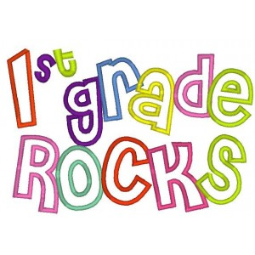 | Core:  -Early Explorers and Settlers  *The story of Columbus’s first voyage to the Americas  *Spain’s search for gold in Mexico and America  *The conquests of Cortes and Pizarro  *The story of the Lost Colony of Roanoke and the founding of Jamestown  *The Pilgrims’ voyage on the Mayflower  *The founding of Massachusetts Bay Colony by the Puritans  Upcoming Dates:  -Friday, November 10th- No School (Staff Work Day)  -November 20th-24th- Thanksgiving Break  Specials Schedule:  Monday, 11/06- Art  Tuesday, 11/07- Music/P.E.  Wednesday, 11/08- Tech/Library  Thursday, 11/09- P.E./Music  Friday, 11/10- No School

